Lab 5: Implementing the Product Microservice
Activity Practice 1: Project Setup and Data Modeling
Define Data Model (Schema)
Product Service owns the entire database.db_product, including the following tables:
Board | Describe
products | Product information: name, price, description, image
categories | Product categories: Sneakers, Running, Classic...
brands | Brands: Nike, Adidas, Puma...
product_stock | Inventory by size for each product
suppliers | Supplier of goods
import_receipts | Goods receipt from supplier
import_receipt_items | Details of each item in the receipt

Product Model:
javascript
// productModel.js — Tầng Business Logic
class Product {
constructor(id, name, description, price,
category_id, brand_id, image_url, stocks) {
this.id = id;
this.name = name;
this.description = description;
this.price = price;
this.category_id = category_id;
this.brand_id = brand_id;
this.image_url = image_url;
this.stocks = stocks || []; // [{size, quantity}]
}

toDict() {
return {
id: this.id, name: this.name,
description: this.description, price: this.price,
category_id: this.category_id, brand_id: this.brand_id,
image_url: this.image_url, stocks: this.stocks,
total_stock: this.stocks.reduce((s, i) => s + i.quantity, 0)
};
}
}

Activity Practice 2: Implementing the Service API
Three-tier architecture in Product Service

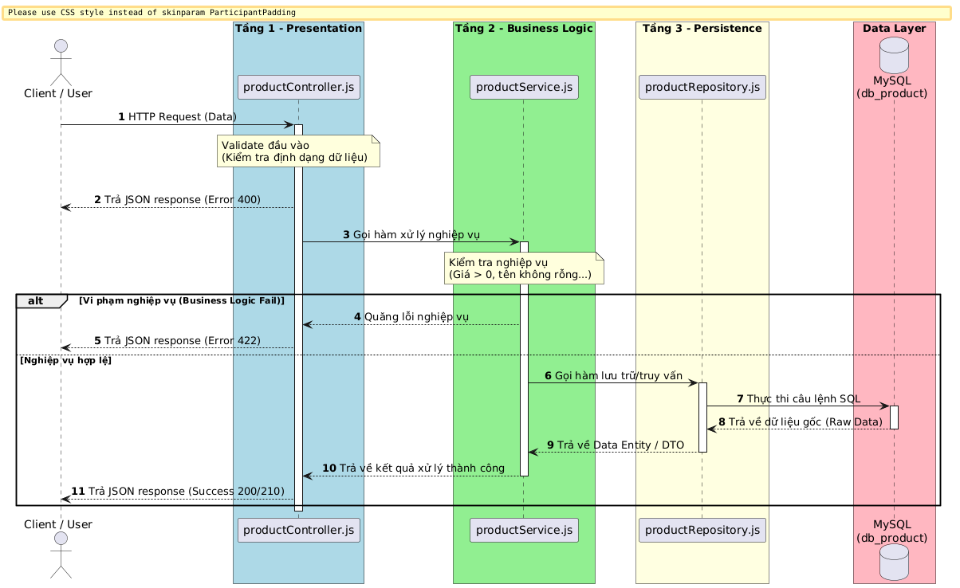

Product Service API Endpoints
Method | Endpoint | Describe | Processing layer
GET | /products | Get a list, supports filtering by brand/category/price/name | Controller → Service → Repository
GET | /products/:id | Get details of a single product, including its inventory and size. | Controller → Service → Repository
POST | /products | Add a new product (Admin) | Controller → Service → Repository
PUT | /products/:id | Product Update (Admin) | Controller → Service → Repository
DELETE | /products/:id | Delete product (Admin) | Controller → Service → Repository
GET | /categories | Get the list of categories | Controller → Repository
POST | /categories | Add a new category | Controller → Repository
GET | /brands | Get a list of brands | Controller → Repository
POST | /brands | Add a new brand. | Controller → Repository
GET | /inventory | View inventory by product and size | Controller → Repository
GET | /inventory/low-stock | Product is running out of stock (≤ 5 pairs) | Controller → Repository
POST | /inventory/deduct | Except for stock when placing an order (call Order Service) | Controller → Service → Repository
POST | /inventory/restore | Return to warehouse upon order cancellation. | Controller → Service → Repository
GET | /suppliers | Supplier list | Controller → Repository
POST | /suppliers | Add a supplier | Controller → Repository
GET | /imports | List of goods receipt slips | Controller → Repository
POST | /imports | Create a purchase order and add up inventory. | Controller → Service → Repository

GET /products processing flow (Retrieves the list of products)
Client gửi: GET /products?search=Nike&brand_id=1&page=1

[Level 1 - productController.js]
- Đọc query params: search, brand_id, category_id, min_price, max_price, page
- Gọi productService.getAllProducts(params)

[Level 2 - productService.js]
- There are no specific business rules here.
- Gọi productRepository.findAll(params)

[Level 3 - productRepository.js]
- Build dynamic SQL statements:
SELECT p.*, c.name as category_name, b.name as brand_name
FROM products p
LEFT JOIN categories c ON p.category_id = c.id
LEFT JOIN brands b ON p.brand_id = b.id
WHERE p.name LIKE '%Nike%' AND p.brand_id = 1
ORDER BY p.created_at DESC LIMIT 12 OFFSET 0
- For each product, add the following query:
SELECT size, quantity FROM product_stock WHERE product_id = ?

[Return]
{
success: true,
products: [...],
total: 5,
page: 1,
totalPages: 1
}
The POST /imports processing flow (Creates a goods receipt)
Client sends: POST /imports
Body: { supplier_id: 1, note: "...", items: [{product_id:1, size:"40", quantity:10}] }

[Level 1 - Controller]
- Check that supplier_id and items are not empty.
- Call importService.createImport(data)

[Floor 2 - Service]
- Start MySQL Transaction
- INSERT into import_receipts
- INSERT vào import_receipt_items
- Update product_stock (add quantity by size)
- Commit Transaction

[Floor 3 - Repository]
- Execute SQL statements within the transaction
- Use ON DUPLICATE KEY UPDATE to add inventory:
INSERT INTO product_stock (product_id, size, quantity)
VALUES (?, ?, ?)
ON DUPLICATE KEY UPDATE quantity = quantity + ?

[Return]
{ success: true, message: "Receipt created successfully!", id: 1 }

Activity Practice 3: Isolation Testing
How to run a standalone Product Service
bash
Step 1: Go to the folder
cd product-service

Step 2: Install dependencies
npm install

Step 3: Configure the .env file
# DB_PASSWORD=your_password

Step 4: Run the service
npm run dev

# Result:
# ✅ Product Service running on port 5003
Test endpoints using cURL.
Test 1 — Get the product list:
bash
curl -X GET http://localhost:5003/products
Expected results:HTTP 200 — JSON array containing a list of products with inventory levels by size

Test 2 — Search for products by name:
bash
curl -X GET "http://localhost:5003/products?search=Nike"
Expected results:HTTP 200 — Returns only products whose names contain "Nike"

Test 3 — Filter by brand and price range:
bash
curl -X GET "http://localhost:5003/products?brand_id=1&min_price=2000000&max_price=3000000"
Expected results:HTTP 200 — Nike products in the 2-3 million VND price range.

Test 4 — Retrieve product details by ID:
bash
curl -X GET http://localhost:5003/products/1
Expected results:
json
{
"success": true,
"product": {
"id": 1,
"name": "Nike Air Max 270",
"price": 2500000,
"category_name": "Sneaker",
"brand_name": "Nike",
"stocks": [
{ "size": "39", "quantity": 10 },
{ "size": "40", "quantity": 15 },
{ "size": "41", "quantity": 12 }
],
"total_stock": 37
}
}

Test 5 — Product does not exist:
bash
curl -X GET http://localhost:5003/products/999
Expected results: HTTP 404
json
{ "success": false, "message": "Product not found." }

Test 6 — Adding a new product (Admin):
bash
curl -X POST http://localhost:5003/products \
-H "Content-Type: application/json" \
-d '{
"name": "Nike Air Force 1",
"price": 2200000,
"category_id": 1,
"brand_id": 1,
"sizes": ["38","39","40","41","42"]
}'
Expected results:HTTP 201 — Product created with inventory = 0 for each size

Test 7 — Check inventory for out-of-stock warnings:
bash
curl -X GET http://localhost:5003/inventory/low-stock
Expected results:HTTP 200 — List of products with stock ≤ 5 pairs

Test 8 — Create a goods receipt form:
bash
curl -X POST http://localhost:5003/imports \
-H "Content-Type: application/json" \
-d '{
"supplier_id": 1,
"note": "Goods received in June",
"items": [
{ "product_id": 1, "size": "40", "quantity": 20 },
{ "product_id": 1, "size": "41", "quantity": 15 }
]
}'
Expected results:HTTP 201 — Receipt created, inventory of sizes 40 and 41 automatically increases.

